**PERTEMUAN 6**

**PENGANTAR JARINGAN KOMPUTER**

**PENGALAMATAN TOPOLOGY**



**Disusun oleh:**

**Fauzi Ikhsan Fajar Muzaqi 2022320018**

**PROGRAM STUDI SISTEM INFORMASI**

**FAKULTAS INFORMATIKA**

**UNIVERSITAS BINA INSANI**

**BEKASI**

**2022**

**Buatlah pengalamatan dan menentukan gateway dari topology di bawah ini**

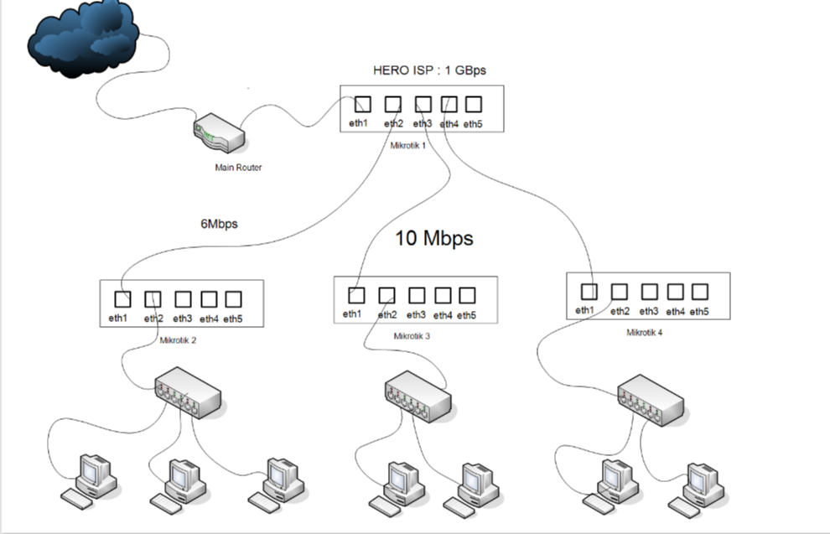

|  |  |  |  |  |  |
| --- | --- | --- | --- | --- | --- |
| **IP ADDRESS : 192.168.10.0/24 | SUBNETMASK : 255.255.255.0** | | | | | |
| **MAIN ROUTER ⇨ MIKROTIK 1 (GATEWAY) : 192.168.10.1** | | | | | |
| **MIK 1 ⇨ MIK 2 192.168.10.2** | | **MIK 1 ⇨ MIK 3 192.168.10.3** | | **MIK 1 ⇨ MIK 4 192.168.10.4** | |
| **MIK 2 ⇨ SW (GATEWAY)**  **192.168.20.1** | | **MIK 3 ⇨ SW (GATEWAY)**  **192.168.30.1** | | **MIK 4 ⇨ SW (GATEWAY)**  **192.168.40.1** | |
| **SW⇨PC1** | **192.168.20.2** | **SW⇨PC1** | **192.168.30.2** | **SW⇨PC1** | **192.168.40.2** |
| **SW⇨PC2** | **192.168.20.3** | **SW⇨PC2** | **192.168.30.3** | **SW⇨PC2** | **192.168.40.3** |
| **SW⇨PC3** | **192.168.20.4** |  | | | |

|  |  |
| --- | --- |
| **KETERANGAN WARNA** | |
|  | Internet Service Provider |
|  | Gateway |
|  | Host Gateway |
| **KATA KUNCI** | |
| **MIK** | Mikrotik |
| **SW** | Switch |
| **PC** | Personal Computer |

**GAMBARAN BERDASARKAN TABEL DI ATAS**

**192.168.10.0/24**

**255.255.255.0**



**192.168.40.3**

**192.168.40.2**

**192.168.30.3**

**192.168.30.2**

**192.168.20.4**

**192.168.20.3**

**192.168.20.2**

**192.168.40.1**

**192.168.30.1**

**192.168.20.1**

**192.168.10.4**

**192.168.10.3**

**192.168.10.2**

**192.168.10.1**